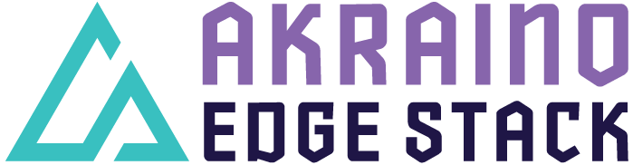

Akraino R4 includes XX blueprints (X new blueprints, and updates and improvements to X existing R1 blueprints) that support a variety of edge use cases across virtualized and container workloads, from connected vehicles to X, to Y to Z. These blueprints are tested and validated on real hardware supported by users and community members.

Kubernetes-Native Infrastructure for Provider Access Edge

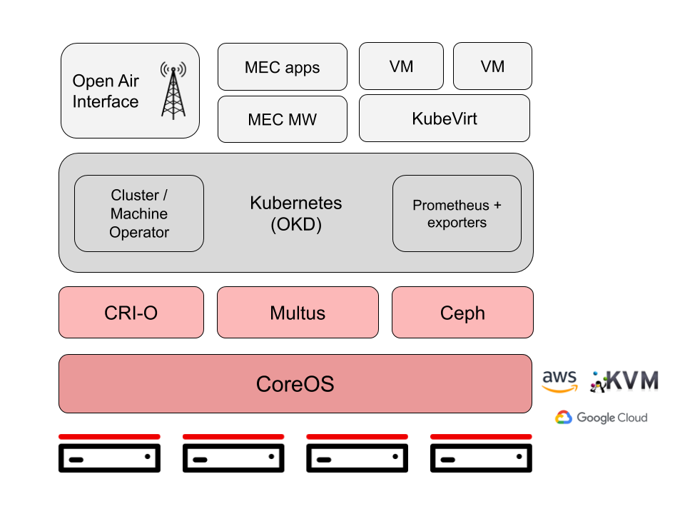

Blueprints in the Kubernetes-Native Infrastructure for Edge family leverage the best-practices and tools from the Kubernetes community to declaratively and consistently manage edge computing stacks from the infrastructure up to the workloads.
They support both containerized and VM-based applications on a common infrastructure and lifecycle-manage these applications using the Operator framework. Building on the Kubernetes Machine API allows users to deploy them consistently anywhere, from VMs in developer environments to bare metal production environments and from on-prem to public cloud.

The family’s Provider Access Edge blueprint targets vRAN and MEC (e.g. AR/VR, machine learning, etc.) use cases. Its key features are:

• Lightweight, self-managing clusters based on CoreOS and Kubernetes (OKD distro)
• Support for VMs (via KubeVirt) and containers on a common infrastructure
• Application lifecycle management using the Operator Framework
• Native support of RT-Kernel workers on CoreOS
• High performance optimizations (hugepages, CPU topology management, etc.)
• Support for multiple networks using Multus, including fast dataplane like SRIOV, DPDK, etc.

For more information: https://wiki.akraino.org/display/AK/Provider+Access+Edge+%28PAE%29+Blueprint

Akraino R4 is now available! For more information: https://www.lfedge.org/projects/akraino/ or https://wiki.akraino.org/

[BACK]

Akraino Edge Stack is an open source project under the LF Edge umbrella that creates edge software stacks that supports high-availability cloud services optimized for edge computing systems and applications. It offers users new levels of flexibility to scale edge cloud services quickly, to maximize the applications and functions supported at the edge, and to help ensure the reliability of systems that must be up at all times. The Akraino Edge Stack platform integrates multiple open source projects to supply a holistic Edge Platform, Edge Application, and Developer APIs ecosystem.

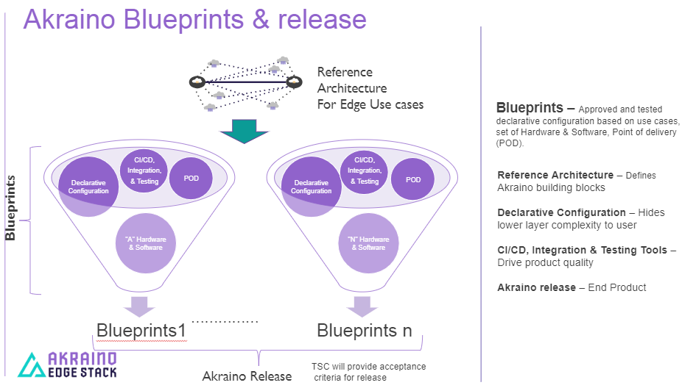

- Akraino uses the “blueprint” concept to address specific Edge use cases to support an end-to-end solution.
- A blueprint is a declarative configuration of the entire stack-- i.e., edge platform that can support edge workloads and edge APIs.
- To address specific use cases, a blueprint architecture is developed by the community and a declarative configuration is used to define all the components used within that architecture such as hardware, software, tools to manage the entire stack, and method of deployment (Blueprints are maintained using full CI/CD integration and testing by the community for ready download and install).

For more information: https://www.lfedge.org/projects/akraino/ or https://wiki.akraino.org/.

[SIDEBAR]


Akraino is part of the LF Edge umbrella organization that establishes an open, interoperable framework for edge computing independent of hardware, silicon, cloud, or operating system. By bringing together industry leaders, LF Edge creates a common framework for hardware and software standards and best practices critical to sustaining current and future generations of IoT and edge devices.

LF Edge Projects address the challenge of industry fragmentation, and collaborates with end users, vendors, and developers to transform all aspects of the edge and accelerate open source developments.

[Insert Logos for: Akraino, Baetly, Fledge, EdgeX Foundry, Glossary of Edge Computing Home Edge, Project EVE]

www.lfedge.org

